**CHAPTER 3**

**REQUIREMENT SPECIFICATION**

**3.1. Introduction:**

The requirements specification is a technical specification of requirements for the software products. It is the first step in the requirements analysis process it lists the requirements of a particular software system including functional, performance and security requirements. The requirements also provide usage scenarios from a user, an operational and an administrative perspective. The purpose of software requirements specification is to provide a detailed overview of the software project, its parameters and goals. This describes the project target audience and its user interface, hardware and software requirements. It defines how the client, team and audience see the project and its functionality.

**3.2. Hardware and Software Specification:**

**3.1.1. Hardware Requirement**

**○** Hard Disk : 256 GB

**○** RAM : 4GB (minimum)

**○** Processor : i3 5th Gen and above

**○** Minimum 2 android mobile phone with Data Connection

**3.1.2. Software Requirement**

**○** Windows 7 OS and above

**○** Android Studio / Eclipse

**3.3. Technologies Used:**

**○** JAVA

**○** Android

**3.3.1. JAVA**

Java is an object-oriented programming language developed initially by James Gosling and colleagues at Sun Microsystems. The language, initially called Oak (named after the oak trees outside Gosling's office), was intended to replace C++, although the feature set better resembles that of Objective C.

**3.3.1.1 INTRODUCTION TO JAVA**

Java has been around since 1991, developed by a small team of Sun Microsystems developers in a project originally called the Green project. The intent of the project was to develop a platform-independent software technology that would be used in the consumer electronics industry. The language that the team created was originally called Oak.

The first implementation of Oak was in a PDA-type device called Star Seven (\*7) that consisted of the Oak language, an operating system called GreenOS, a user interface, and hardware. The name \*7 was derived from the telephone sequence that was used in the team's office and that was dialed in order to answer any ringing telephone from any other phone in the office.

Around the time the First Person project was floundering in consumer electronics, a new craze was gaining momentum in America; the craze was called "Web surfing." The World Wide Web, a name applied to the Internet's millions of linked HTML documents was suddenly becoming popular for use by the masses. The reason for this was the introduction of a graphical Web browser called Mosaic, developed by ncSA. The browser simplified Web browsing by combining text and graphics into a single interface to eliminate the need for users to learn many confusing UNIX and DOS commands. Navigating around the Web was much easier using Mosaic.

It has only been since 1994 that Oak technology has been applied to the Web. In 1994, two Sun developers created the first version of Hot Java, and then called Web Runner, which is a graphical browser for the Web that exists today. The browser was coded entirely in the Oak language, by this time called Java. Soon after, the Java compiler was rewritten in the Java language from its original C code, thus proving that Java could be used effectively as an application language. Sun introduced Java in May 1995 at the Sun World 95 convention.

Web surfing has become an enormously popular practice among millions of computer users. Until Java, however, the content of information on the Internet has been a bland series of HTML documents. Web users are hungry for applications that are interactive, that users can execute no matter what hardware or software platform they are using, and that travel across heterogeneous networks and do not spread viruses to their computers. Java can create such applications.

**3.3.1.2 WORKING OF JAVA**

For those who are new to object-oriented programming, the concept of a class will be new to you. Simplistically, a class is the definition for a segment of code that can contain both data (called attributes) and functions (called methods).

When the interpreter executes a class, it looks for a particular method by the name of **main,** which will sound familiar to C programmers. The main method is passed as a parameter an array of strings (similar to the argv [] of C), and is declared as a static method.

To output text from the program, we execute the **println** method of **System.out,** which is java’s output stream. UNIX users will appreciate the theory behind such a stream, as it is actually standard output. For those who are instead used to the Wintel platform, it will write the string passed to it to the user’s program.

Java consists of two things :

* + Programming language
  + Platform

**3.3.1.3 THE JAVA PROGRAMMING LANGUAGE**

Java is a high-level programming language that is all of the following:

* + Simple
  + Object-oriented
  + Distributed
  + Interpreted
  + Robust
  + Secure
  + Architecture-neutral
  + Portable
  + High-performance
  + Multithreaded
  + Dynamic

The code and can bring about changes whenever felt necessary. Some of the standard needed to achieve the above-mentioned objectives are as follows:

Java is unusual in that each Java program is both co implied and interpreted. With a compiler, you translate a Java program into an intermediate language called **Java byte codes** – the platform independent codes interpreted by the Java interpreter. With an interpreter, each Java byte code instruction is parsed and run on the computer. Compilation happens just once; interpretation occurs each time the program is executed. This figure illustrates how it works:

**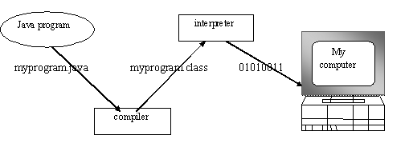**

**Fig.3.1**

You can think of Java byte codes as the machine code instructions for the **Java Virtual Machine (JVM).** Every Java interpreter, whether it’s a Java development tool or a Web browser that can run Java applets, is an implementation of JVM. That JVM can also be implemented in hardware. Java byte codes help make “write once, run anywhere” possible.

You can compile your Java program into byte codes on any platform that has a Java compiler. The byte codes can then be run on any implementation of the JVM. For example, that same Java program can e run on Windows NT, Solaris and Macintos

Java program

Complier

Interpreter

Interpreter

Interpreter

**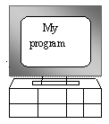  **

**PC-Compatible Sun Ultra Solaris Power macintosh**

**Windows NT System 8**

**3.3.1.4 THE JAVA PLATFORM**

A platform is the hardware or software environment in which a program runs. The Java platform differs from most other platforms in that it’s a software-only platform that runs on top of other, hardware-based platforms. Most other platforms are described as a combination of hardware and operating system.

The Java platform has two components :

* The Java Virtual Machine (JVM)
* The Java Application Programming Interface (Java API)

You’ve already been introduced to the JVM. It’s the base for the Java platform and is ported onto various hardware-based platforms.

The Java API is a large collection of ready-made software components that provide many useful capabilities, such as graphical user interface (GUI) widgets. The Java API is grouped into libraries **(packages)** of related components. The following figure depicts a Java program, such as an application or applet, that’s running on the Java platform. As the figure shows, the Java API and Virtual Machine insulates the Java program from hardware dependencies.

**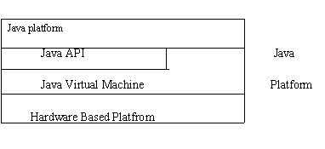**

Fig.3.3

As a platform-independent environment, Java can be a bit slower than native code. However, smart compliers, weel-tuned interpreters, and just-in-time byte compilers can bring Java’s performance close to that of native code without threatening portability.

### 

### 3.3.3 Android Introduction:

Android is a Linux based operating system it is designed primarily for touch screen mobile devices such as smart phones and tablet computers. The operating system has developed a lot in last 15 years starting from black and white phones to recent smart phones or mini computers. One of the most widely used mobile OS   these days is android.  The android is software that was founded in Palo Alto of California in 2003.

The android is a powerful operating system and it supports large number of applications in Smartphones. These applications are more comfortable and advanced for the users. The hardware that supports android software is based on ARM architecture platform. The android is an open source operating system means that it’s free and any one can use it. The android has got millions of apps available that can help you managing your life one or other way and it is available low cost in market at that reasons android is very popular.

The android development supports with the full java programming language. Even other packages that are API and JSE are not supported. The first version 1.0 of android development kit (SDK) was released in 2008 and latest updated version is jelly bean.

The android is a operating system and is a stack of software components which is divided into five sections and four main layers that is

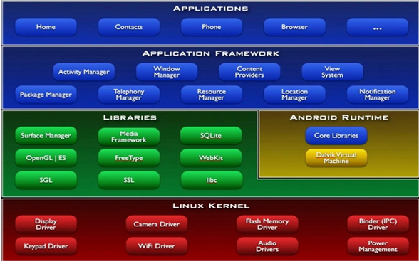

### 3.3.3.1 Linux kernel:

The android uses the powerful Linux kernel and it supports wide range of hardware drivers. The kernel is the heart of the operating system that manages input and output requests from software. This provides basic system functionalities like process management, memory management, device management like camera, keypad, display etc the kernel handles all the things. The Linux is really good at networking and it is not necessary to interface it to the peripheral hardware. The kernel itself does not interact directly with the user but rather interacts with the shell and other programs as well as with the hard ware devices on the system.

### 3.3.3.2 Libraries:

The on top of a Linux kennel there is a set of libraries including open source web browser such as webkit, library libc. These libraries are used to play and record audio and video. The SQLite is a data base which is useful for storage and sharing of application data. The SSL libraries are responsible for internet security etc.

### 3.3.3.3 Android Runtime:

The android runtime provides a key component called Dalvik Virtual Machine which is a kind of java virtual machine. It is specially designed and optimized for android. The Dalvik VM is the process virtual machine in the android operating system. It is software that runs apps on android devices.

The Dalvik VM makes use of Linux core features like memory management and multithreading which is in a java language. The Dalvik VM enables every android application to run it own process. The Dalvik VM executes the files in the .dex format.

### 3.3.3.4 Application frame work:

The application frame work layer provides many higher level services to applications such as windows manager, view system, package manager, resource manager etc. The application developers are allowed to make use of these services in their application.

### 3.3.3.5 Applications:

You will find all [the android applications](https://www.edgefxkits.com/home-automation-by-android-application-based-remote-control?utm_source=elprocus.com" \t "_blank) at the top layer and you will write your application and install on this layer. Examples of such applications are contacts, books, browsers, services etc. Each application performs a different role in the overall applications.

**Advantages:**

* Android is Linux based open source operating system , it can be developed by any one
* Easy access to the android apps
* You can replace the battery and mass storage, disk drive and UDB option
* Its supports all Google services
* The operating system is able to inform you of a new SMS and Emails or latest updates.
* It supports Multitasking
* Android phone can also function as a router to share internet
* Its free to customize
* Can install a modified ROM

Its supports 2D and 3D graphics